Hayden, Joshua, Jade, Jacob

**Guidebook to Image Processing Techniques**

**Image Enhancing**

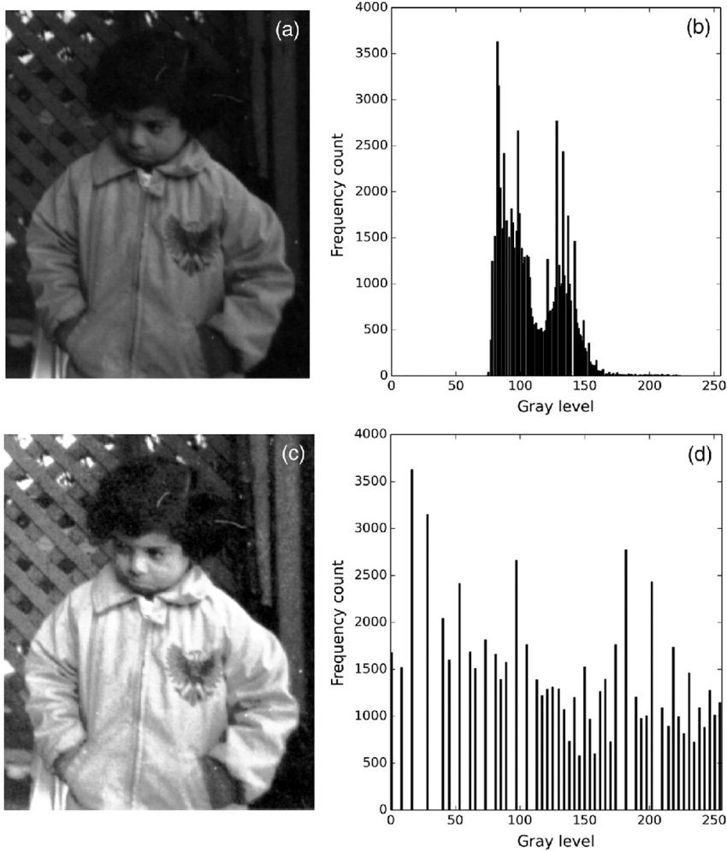

Histogram Equalization:

* Description: The contrast of a picture can be made better with histogram equalization, which spreads out the intensity values more widely across the histogram. It works particularly well when the image's contrast is poor or concentrated in a specific range of intensities.
* Real-World Example: This technique is often used in medical imaging to improve the contrast of X-ray or MRI scans, making it easier to detect abnormalities. It’s also used in satellite imagery to enhance the visibility of terrain features in overexposed or underexposed images.

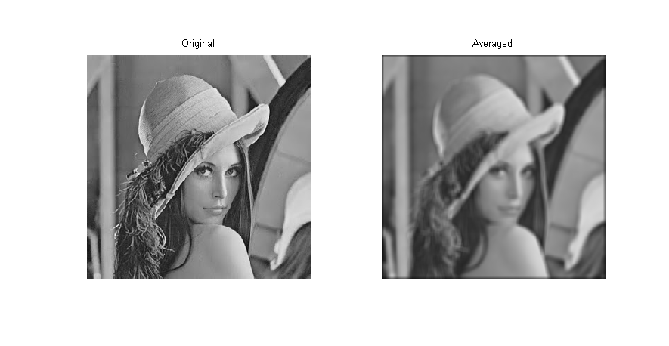

Smoothing:

* Description: Smoothing, also known as blurring, reduces noise in an image by averaging the pixel values with their neighbors. Common filters for smoothing include Gaussian and Median filters.
* Real-World Example: Smoothing is frequently used in photography to reduce graininess in low-light images. It’s also applied in facial recognition software to smooth out skin textures, making facial features more prominent for detection algorithms.

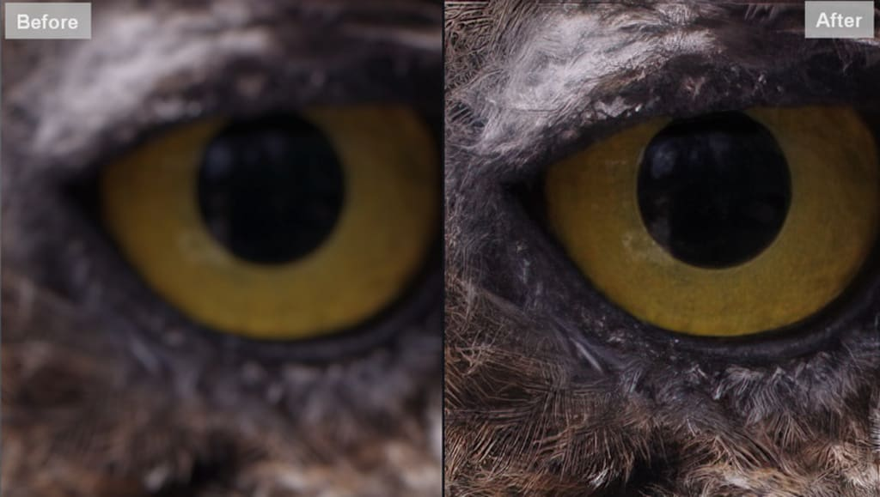

Sharpening:

* Description: Sharpening enhances the edges in an image, making details more defined. The Laplacian filter is commonly used to detect rapid changes in pixel intensity to emphasize edges.
* Real-World Example: Sharpening is used in industrial quality control to detect defects in manufactured products. It’s also used in text recognition systems to enhance the clarity of scanned documents, improving the accuracy of Optical Character Recognition (OCR).

**Image Segmentation**

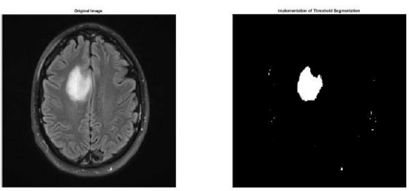

Thresholding:

* Description: Thresholding is one of the most simple methods to segment images. Thresholding converts a grayscale image into a binary image, via specific threshold values. All pixels are separated into binary, for example 1 being white, 0 being darker than 1’s value.
* Real-World Example: The first example that comes to mind is medical imagery, more specifically, MRI scans. These scans, with thresholding, help in distinguishing different tissue types.

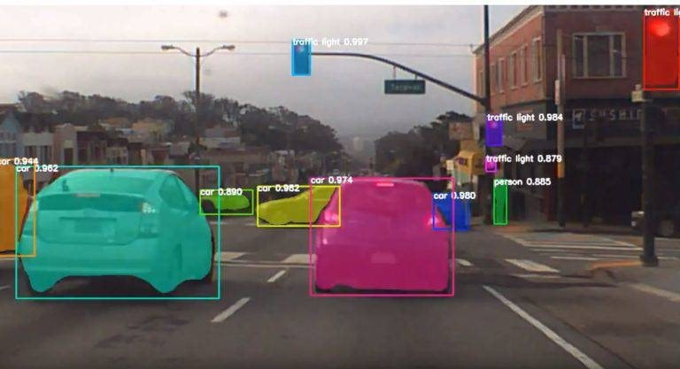

Edge Detection:

* Description: When using computer vision, edge detection is important for telling the computer where objects begin and end. Edge detection analyzes and gradients in the image, and uses sharp or sudden color changes to identify edges of objects.
* Real-World Example: One of the most publicly known examples is edge detection in self-driving cars. By successfully observing lanes, vehicles, and objects, autonomous cars, like tesla, can avoid collisions with surrounding objects.

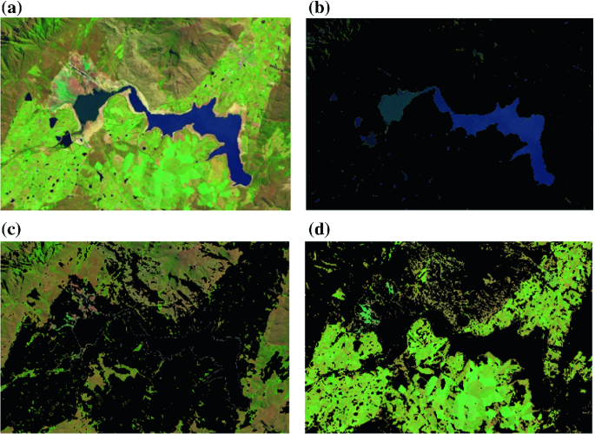

Clustering:

* Description: Clustering is a segmentation technique that groups similar pixels, by measuring color or intensity, into “clusters”. This technique helps the computers segment more automatically. While researching, one of the most popular methods seemed to be K-sampling.
* Real-World Example: Clustering is used for computer vision in satellites, to group land types. For example, when taking alarge shot of earth, it can group forests, urban areas, or bodies of water. By grouping these similar pixel intensities, we can classify different regions depending onit’s characteristics.

**Image Restoration**

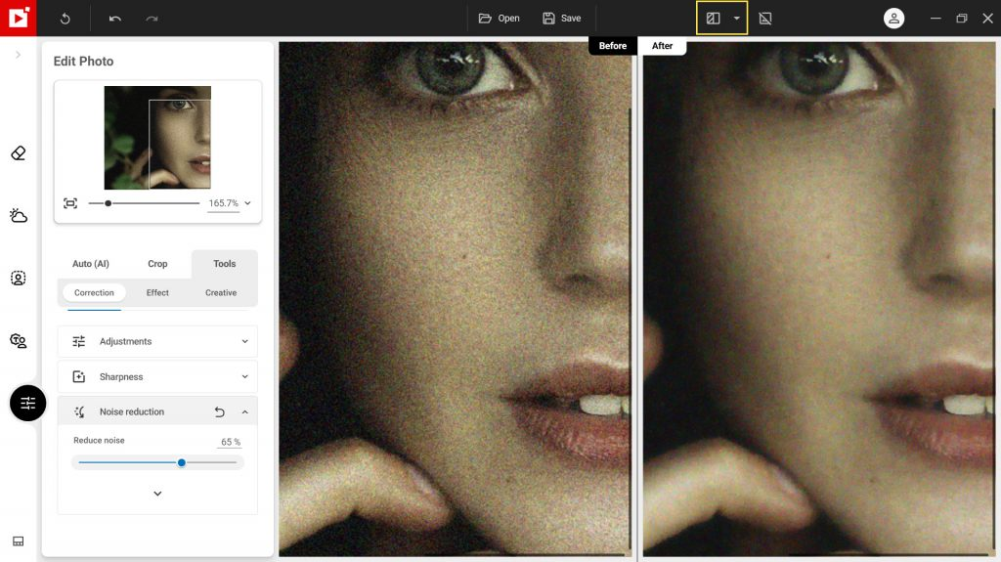

Noise Reduction:

* Description: Involves methods that help clean up images by removing unwanted disturbances, or "noise," before or during the process of dividing an image into distinct sections or objects
* Real-World Example: In medical imaging for MRI or CT scans, physicians analyze images to diagnose conditions like tumors or other abnormalities. However, these images often include noise caused by factors such as electronic interference or patient movement.

Deblurring:

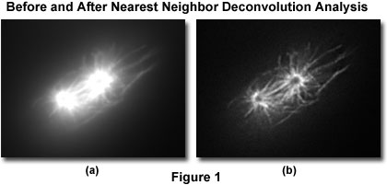

* Description: Image restoration deblurring is a method focused on enhancing image quality by eliminating blur that may have occurred during capture.
* Real-World Example: Analyst using deblurring technique like the photo above to enhance the quality of the image. Above is an example of a ***Xenopus*** before and after image being deblurred.

Inpainting:

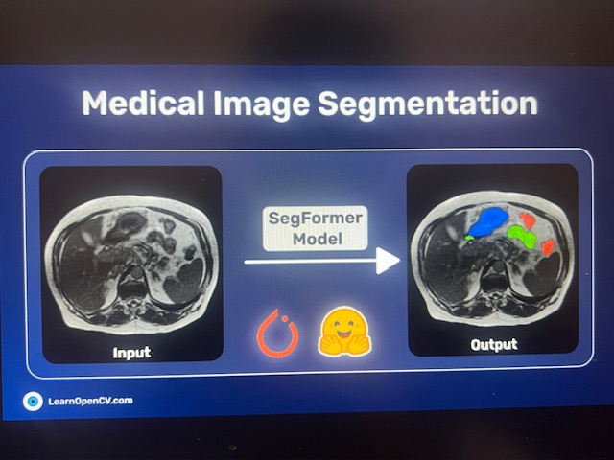

* Description: Inpainting is the technique used to restore lost or damaged areas of an image. It is commonly employed to fix images that have scratches, stains, or missing sections
* Real-World Example: The image above is an example of an inpainting tool in digital art software that selected the smudged area, allowing the software to fill it in with the appropriate colors from the surrounding area.

**Image Compression**

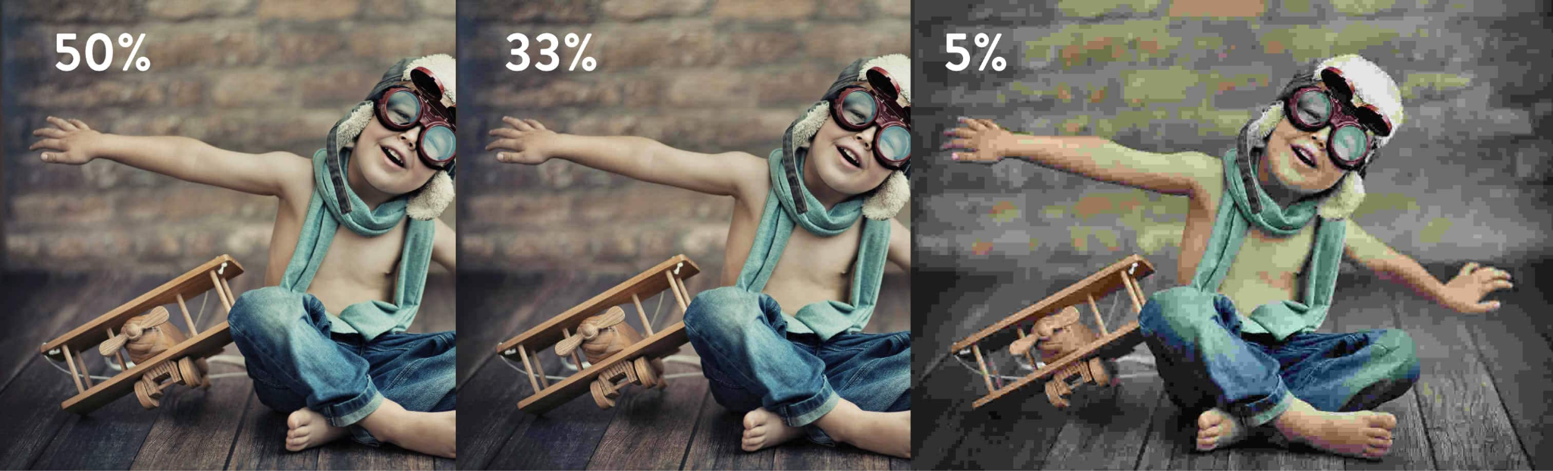

Lossy Compression:

* Description: Lossy compression shrinks a picture file by getting rid of some of its data, usually by throwing away less important visual information. JPEG is a standard format that uses lossy compression.
* Real-World Example: Lossy compression is widely used in social media platforms, where high-quality images are often compressed to reduce storage and transmission costs. It’s also used i n web design to improve page load times by compressing images without significantly reducing quality.

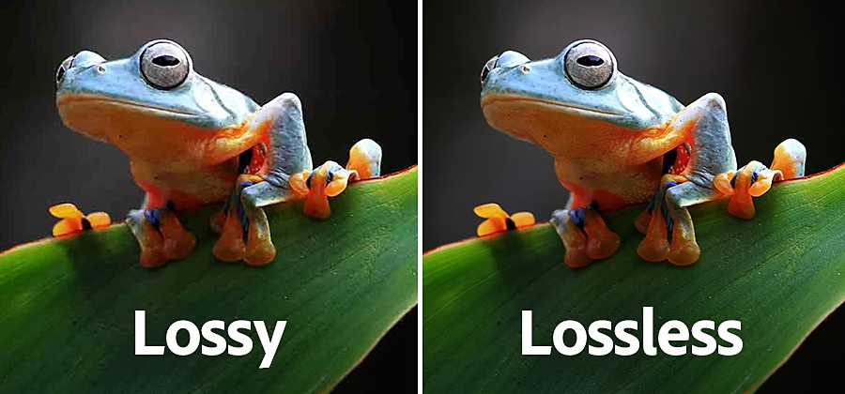

Lossless Compression:

* Description: The lossless method of image compression makes certain that all original data is retained. This means that the image based on a compressed form can be restored in its original form later. Here, unlike lossy compression, there is no loss of any visual information. The PNG and GIF formats utilize lossless compression techniques.
* Real-World Example: Lossless compression techniques are mostly employed wherever images are cared about fully, and no data should be thrown away. It is often used, for instance, in the medical field as well as on technical drawings in which every pixel counts. PNG file formats are often utilized in graphic design as logos and images with transparent backgrounds since they are non-lossy.

-------------------------------------------------------------------------------------------------------------------------------

**Our Reflections**

When I first started researching image enhancement techniques, I was surprised at how even the most minor adjustments to an image’s contrast or sharpness can result in significant improvements. What stood out to me most was the versatility of these enhancement techniques. They are not only used to improve image aesthetics but also to extract vital information in fields where every detail matters, like healthcare, security, and even space exploration. By exploring the technical side of image enhancement and connecting it to real-world applications, I came to appreciate the broader impact these techniques have on advancing technology and solving complex problems.

* Hayden

This was very exciting doing this assignment; I was able to learn about so many things, more particularly, Noise reduction, deblurring and inpainting. I’ve learned that noise reduction helps with getting rid of any unwanted variations that would lead to a clearer image for the accuracy of an improved segmentation. Deblurring addresses blurry issues caused by any motion that may have happened during the time the pic was taken. I’ve learned that Inpainting restores the damaged or missing sections of a picture or image. Collectively, all 3 of these techniques are used to improve the quality of the image in an accurate and more realistic way.

* Joshua

This investigation of photograph processing strategies has broadened my knowledge of how each method including compression, smoothing and polishing alters pictures for different uses. I found out about some methods where lossless compression is very good for quality while lossy compromises on quality to be effective. Practical cases demonstrated how such approaches are useful within social media, clinical imaging and surveillance. While creating the guidebook, I realized the need of picking the right technique for a particular situation and as a result which made the proportionate and comprehensive balance clearer. All in all, the goal of the task made these intricate concepts such as the balance of these principles more interesting and easier to apply.

- Jade